**Spring 2023: CS5710 – Machine Learning**

In-Class Programming Assignment-2

GitHub Link - <https://github.com/raimukul/MachineLearning_Assignments>

Video link- <https://drive.google.com/file/d/1qp0TJYqW4no51K0m6qG21c5vklvUhooA/view?usp=share_link>

1. Use a python code to display the following star pattern using the for loop.

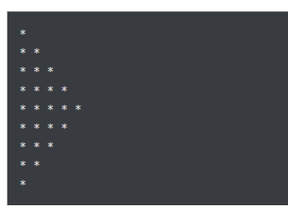

#Define the number of rows.

rows = 5

#Use range in rows by for loop

for i in range(0, rows):

#increase the rows upto 5 and print * on completion of one row

for j in range(0, i + 1):

print("*", end=' ')

print("\r")

#decrease the rows upto 1

for i in range(rows, 0, -1):

for j in range(0, i - 1):

print("*", end=' ')

print("\r")

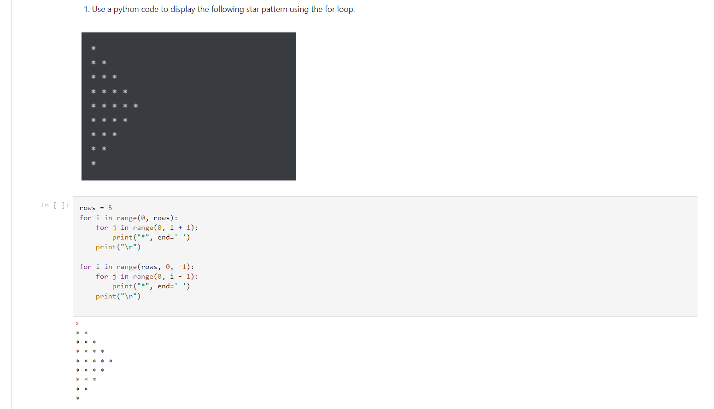

**2. Use looping to output the elements from a provided list present at odd indexes.**

#We define the list

my_list = [10, 20, 30, 40, 50, 60, 70, 80, 90, 100]

*# start from index 1 with step 2( means 1, 3, 5, and so on)*

for i in my_list[1::2]:

print(i, end=" ")

20 40 60 80 100

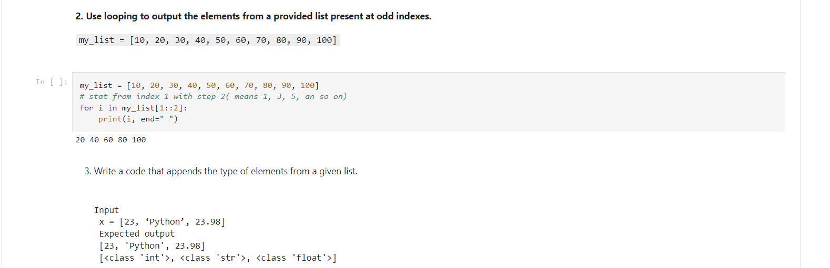

1. **Write a code that appends the type of elements from a given list**

Input

x = [23, ‘Python’, 23.98]

Expected output

[23, 'Python', 23.98]

[<class 'int'>, <class 'str'>, <class 'float'>]

In [ ]:

x = [23, 'Python',23.98]

#create an empty list y.

y = []

for i in range(len(x)):

#appending the data types in list y

y.append(type(x[i]))

print(x)

print(y)

[23, 'Python', 23.98]

[<class 'int'>, <class 'str'>, <class 'float'>]

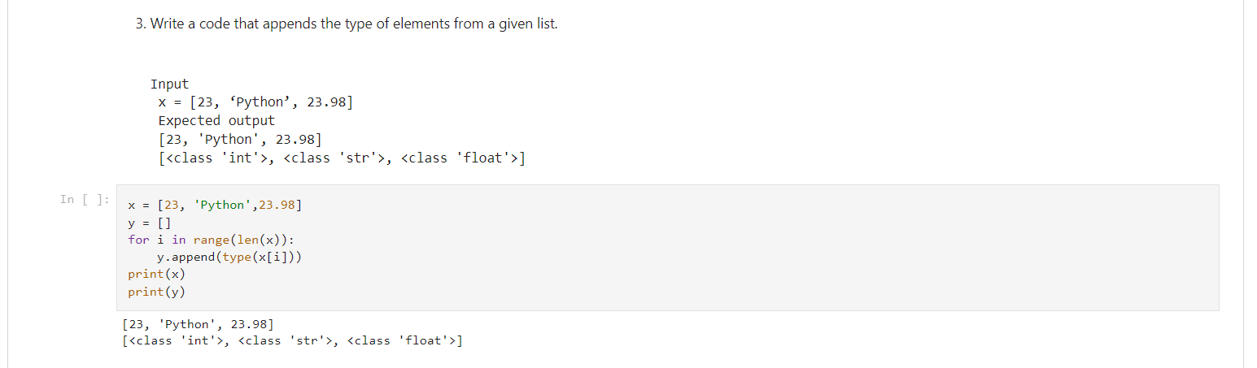

1. **Write a function that takes a list and returns a new list with unique items of the first list.**

Sample List: [1,2,3,3,3,3,4,5]

Unique List: [1, 2, 3, 4, 5]

In [ ]:

def f(list):

a=set(list)

print(sorted(a))

f([1,2,3,3,3,3,4,5])

[1, 2, 3, 4, 5]

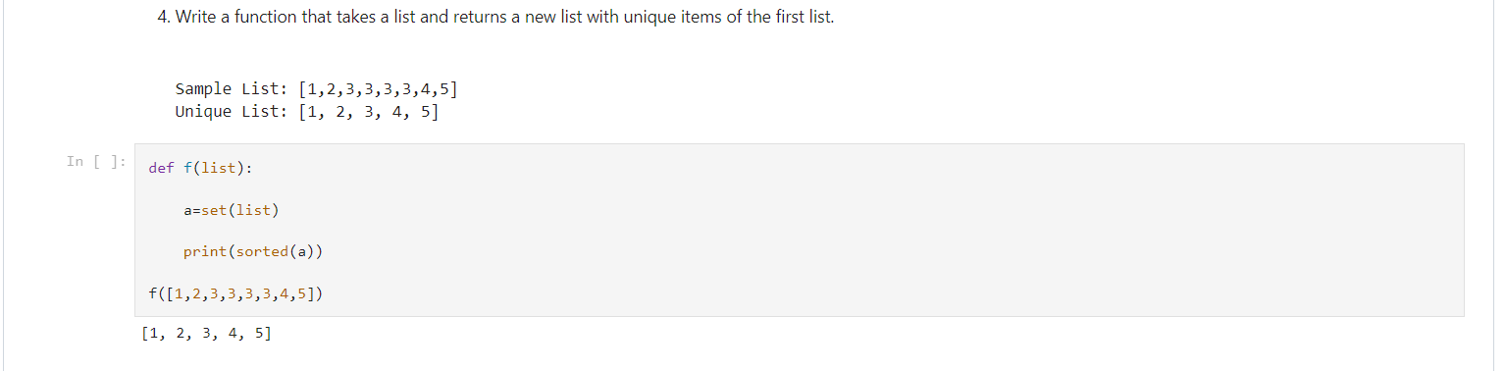

1. Write a function that accepts a string and calculate the number of upper-case letters and lower-case

letters.

Input String: 'The quick Brow Fox'

Expected Output:

No. of Upper-case characters: 3

No. of Lower-case Characters: 12

In [ ]:

def string_test(s):

d={"upperCase":0, "lowerCase":0}

for c in s:

if c.isupper():

d["upperCase"]+=1

elif c.islower():

d["lowerCase"]+=1

else:

pass

print ("Original String : ", s)

print ("No. of Upper-case characters : ", d["upperCase"])

print ("No. of Lower-case Characters : ", d["lowerCase"])

string_test('The quick Brow Fox')

Original String : The quick Brow Fox

No. of Upper-case characters : 3

No. of Lower-case Characters : 12

